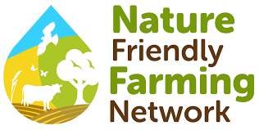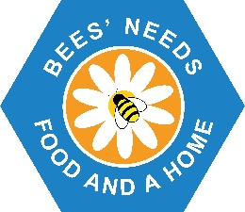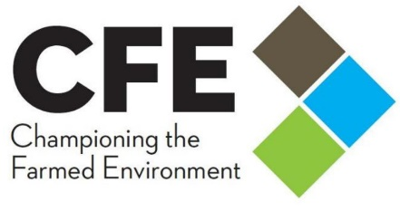
Bees’ Needs Champions Awards 2022 - 2023
Farming Category - Entry Form
Thank you for considering an application to be a Bees’ Needs Champion. The judging panel (Defra, Championing the Farmed Environment, and the Nature Friendly Farming Network) are looking forward to hearing about the wonderful work you have done.
The Champions Awards are a key part of government’s National Pollinator Strategy and Action Plan for 2021-24, produced together with our valued partners. The farming category is a celebration of the wide range of action that farmers have taken for our precious pollinators.
Criteria which will be considered by the judging panel include:
- Evidence of dedication to supporting pollinators
- Innovation and creativity in approach
- Promotion to others / awareness raising of Bees’ Needs
- Evidence of beneficial impact to pollinators on farm and in the wider countryside
Activities linked to agri-environment funding will be considered, but the nomination should describe how a farmer or land manager has demonstrated commitment to benefiting pollinators beyond the prescription of their funded activity.
Name of farm / farming business:
Please describe the measures in place to support pollinators on the farm or in the wider environment: (max 500 words)

What is being achieved by these measures? (max 500 words)
Photographs in support of your application can also be included.
Please return to CFE@nfu.org.uk no later than 14/05/2023

By submitting an application you consent to your information being shared with members of the judging panel, Defra, CFE and NFFN.
If successful, details of your award will be shared publicly.
By attaching photographs you confirm that you have obtained permission from the photographer for Defra, CFE, NFFN and carefully selected organisations to use the attached images (and any subsequently requested) for all purposes of publication, exhibition, press, television, and website coverage of the Bees’ Needs Awards 2022 - 2023; and in particular, for Defra, CFE and NFFN to make copies, retouches, reductions, and enlargements of them without payment or permission.
As far as you are aware, such action by, or on behalf of Defra, CFE and NFFN will not breach any copyright of the image. Defra, NFU, CFE and NFFN reserve the right not to credit the photographer, though usually every effort is made to do so. Where people feature prominently in an image, you confirm that the original photographer was given permission to take the photograph (by a parent or guardian if the subject is under 18 years of age) and can supply signed model release forms if necessary to prove this.

Signed:
Date:

