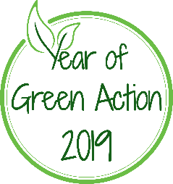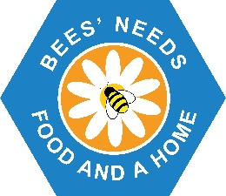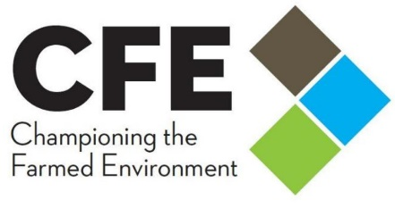
Year of Green Action Bees’ Needs Champions Awards 2019
Farming Category
Nomination Form
Name of farm / farming business: Name of nominee:
Please describe the measures in place to support pollinators on the farm or in the wider environment: (max 300 words)

What is being achieved by these measures? (max 250 words)

Photographs in support of your application can also be included.
Please return to CFE@nfu.org.uk before 10th October 2019
By submitting an application you consent to your information being shared with members of the judging panel, Defra, CFE and NFU. If successful details of your award will be shared publicly.
By attaching photographs you confirm that you have obtained permission from the photographer for Defra, CFE and NFU and carefully selected organisations to use the attached images (and any subsequently requested) for all purposes of publication, exhibition, press, television, and website coverage of the Year of Green Action Bees Needs Awards 2019; and in particular, for Defra, NFU and CFE to make copies, retouches, reductions, and enlargements of them without payment or permission.
As far as you are aware, such action by, or on behalf of Defra, NFU and CFE will not breach any copyright of the image Defra, NFU and CFE reserve the right not to credit the photographer, though usually, every effort is made to do so. Where people feature prominently in an image, you confirm that the original photographer was given permission to take the photograph (by a parent or guardian if the subject is under 18 years of age), and can supply signed model release forms if necessary to prove this.

Signature of applicant:
Date:

